Big Button Mobile Phone with SOS Button 3G

Type of device: Mobile
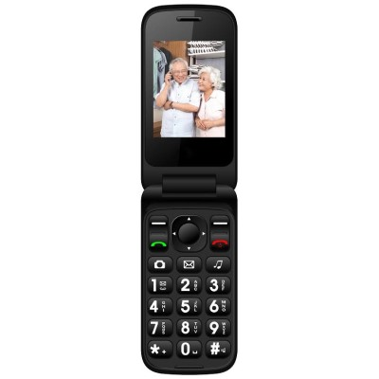

Actual Display Size : 2.4 inches
Button Type : Physical Keypad
Network Capability : 3G
Year of Release : 2019
Average Price : $199 as of 29 05 2020
Other : 0

Accessibility Features:

Cognitive
- Simple Instructions
Simplify Display

Hearing Impairment and Deaf
- Bluetooth or Wi-Fi
- Text Messaging/SMS
- Vibrating Alerts - Adjustable
Visual Alerts - Incoming Calls

Vision
- Battery Alert - Audible
- Bluetooth or Wi-Fi
- Brightness Adjustable
- Key Marker – Raised '5'
- Key Numbers - Standard Layout
- Key Press - Vibration or Click
Power Cue

Speech
- Bluetooth or Wi-Fi
- Messaging Options - Email
Messaging Options - MMS

Physical
- Bluetooth or Wi-Fi
- Guarded/Recessed Keys
- Headset - plug connected
Physical Dialling Keys

How and where to get it from?
You can buy this phone from Big Buttons, and other retailers.

More information is available on:
Big Button Mobile Phone with SOS Button 3G webpage

